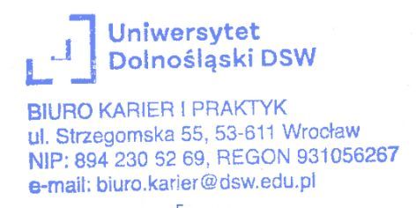
Wrocław, ……………………………………
date

INTERNSHIP REFERRAL

The Lower Silesian University DSW in Wrocław refers Ms./Mr. ,
Student’s name and surname
with register number …..…………, contact number: …………………………… e-mail address ……………………………………… a student of the ……….. semester on ……... year, on the field of …………… the first/second cycle degree studies/uniform studies*, full-time program/part-time program* to an internship ………………………………..…………………………………………… in the dimension of ……….…… teaching hours* internship’s name
(including …………. Teaching hours at the Host Institution) under the “Program and Regulation of Internship” on the given field of study. The referral is given for submitting it to the Host Institution.
 |  | date, signature, and stamp of the Internship Supervisor

* Delete as appropriate
** 1 teaching hour assumes 0,75 of a clock hour

